# **Lab no 7**

# **Flags In Operating System**

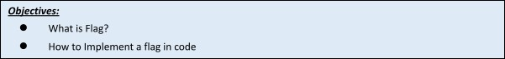

**Flags:**

In computer science, a flag is a value that acts as a signal for a function or process. The value of the flag is used to determine the next step of a program. Flags are often binary flags, which contain a boolean value (true or false). However, not all flags are binary, meaning they can store a range of values.

You can think of a binary flag as a small red flag that is laying flat when it is false, but pops up when it is true. A raised flag says to a program, "Stop - do something different." A common example of a flag in computer programming is a variable in a while loop.



Operating System

2

**When to Implement It?**

Consider following use case:

You want to store data related to a survey.Lets say you capture 'n' number of attributes of all participants.Lets say that one of the attributes is a checkbox that says : “Notify me for future survey”. There are only 2 possible values in such a case, if it is selected then true else false. In this case, one can always use a boolean variable that has 2 values(true/false) to store information. Additionally, this variable can be used to make some decisions in programming based on its value.

Say if true, send out surveys in future. If false, do not do anything.

**Code:**

|  |
| --- |
| cleanest_cities=['karachi','lahore','quetta','islamabad'] |
| keep_looping = True #Flag |
| while keep_looping == True: |
| user_input = input("Enter a city ") |
| for a_clean_city in cleanest_cities: |
| if user_input == a_clean_city:  print("It's one of the cleanest cities") |
| break |
| else: |
| print("Not a clean city") |
| break |
| else: |
| keep_looping = False |

**Task:**

* Write false and see what happens to the code.

* Create a similar code for cleanest countries and apply flags

CODE :

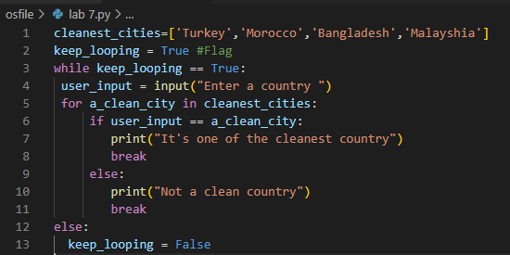

OUTPUT :

